**Name:**

**Roll No:**

**Batch:**

**Date:**

**NETWORKING & SYSTEM ADMINISTRATION LAB**

**Experiment No.: 1**

**Aim**

Install the latest version of Ubuntu on an Oracle VM VirtualBox.

**Procedure**

**STEP 1**

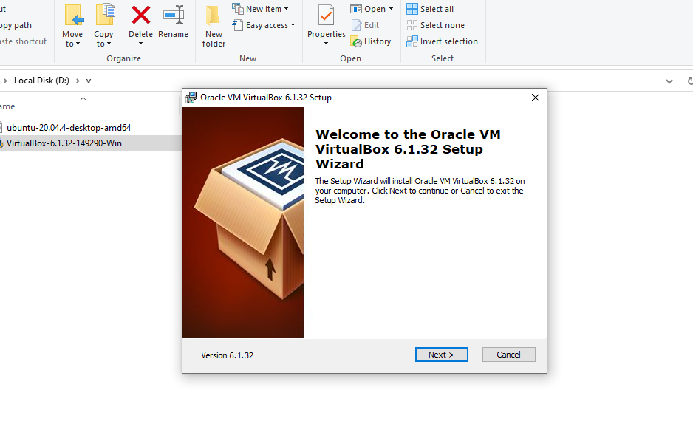

## Click Next

**STEP 2**

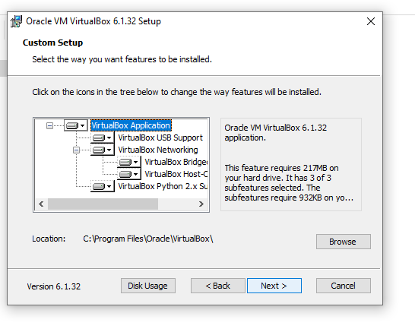

## Click Next

**STEP 3**

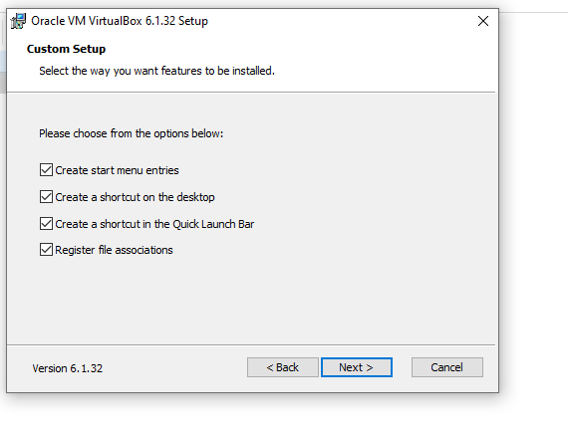

**STEP 4**

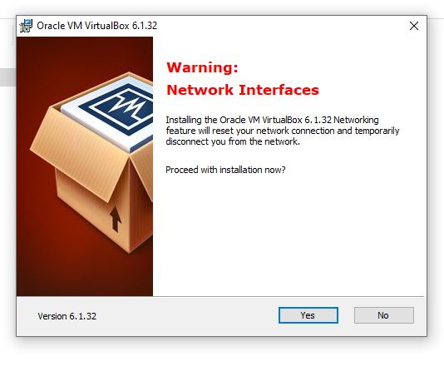

## Click Yes and then Install.

**STEP 5**

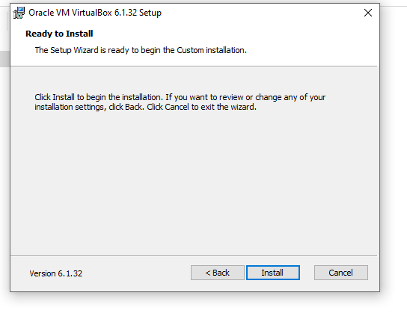

**STEP 6**

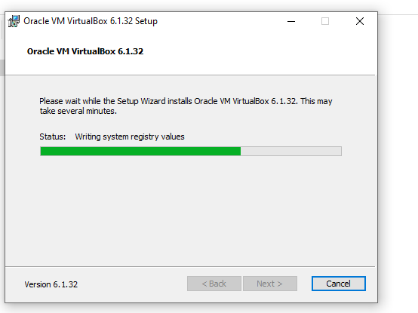

**STEP 7**

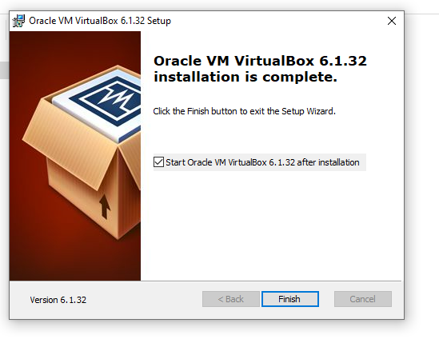

Click Finish

## After completion of Installation process, the Virtual Box Window gets opened

**STEP 8**

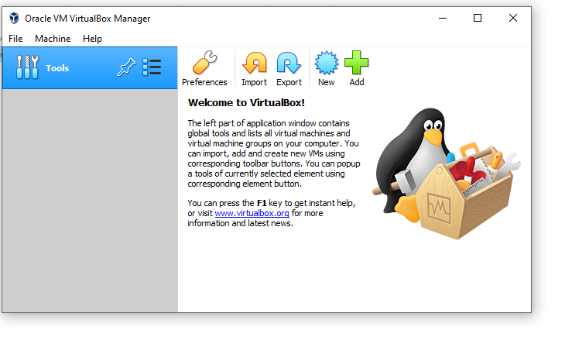

Click New to add OS(Ubuntu) to VirtualBox

**STEP 9**

Enter a new name for your operating system in a prompt window. When you type the name, VirtualBox will automatically detect the type and version of yourOS.However,you can also modify it later on.

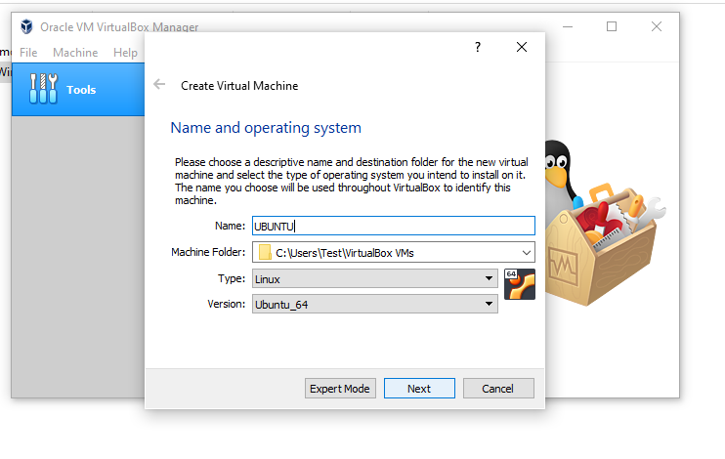

**STEP 10**

Select the RAM size. Here, you have to choose the base memory based on your host system RAM size.

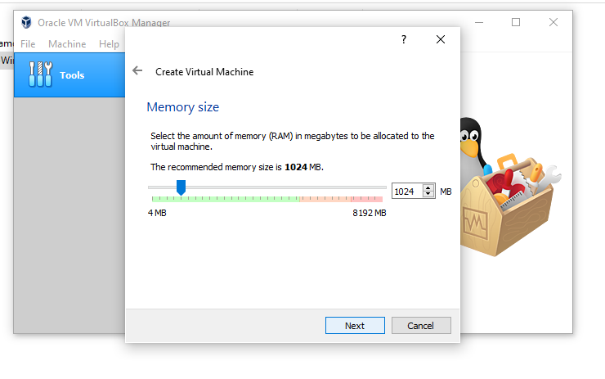

**STEP 11**

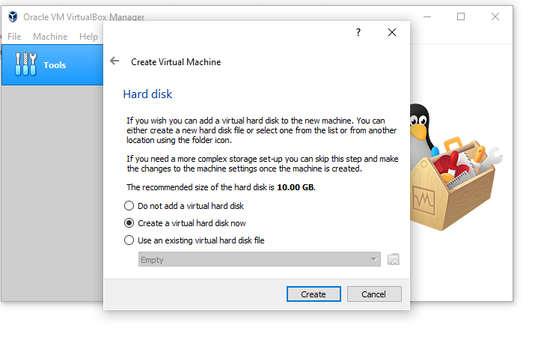

We now continue to allocate space for virtual hard disks. Virtual disks act as a separate hard disk for the virtual machines residing over the host system hard disk drive.

**STEP 12**

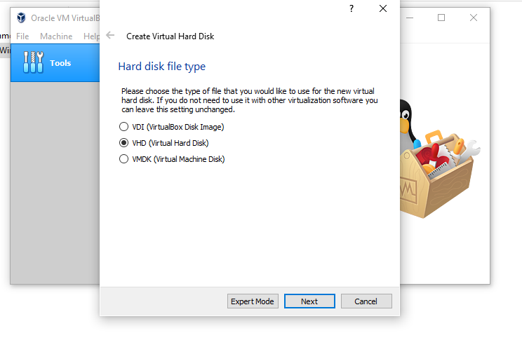

After creating a virtual disk, the next window will prompt you to select the type of file. It decides the method of storing your virtual machine in a file. I’m selecting the VHD

**STEP 14**

Decide the scalability of your virtual hard disk. In the future, if you want to increase your drive space, the dynamic allocation can allow you to do so.

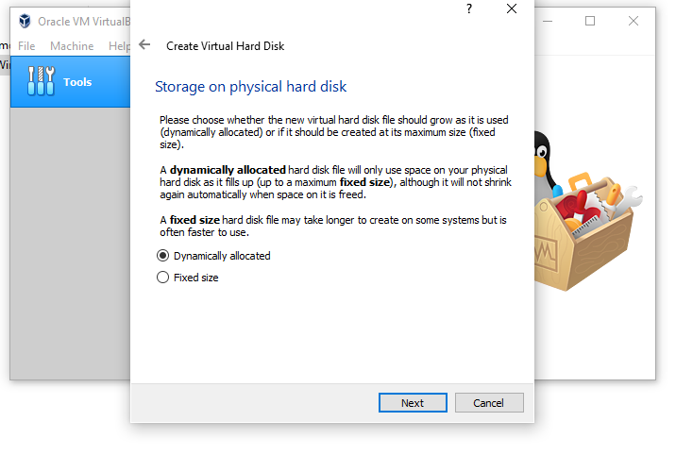

**STEP 15**

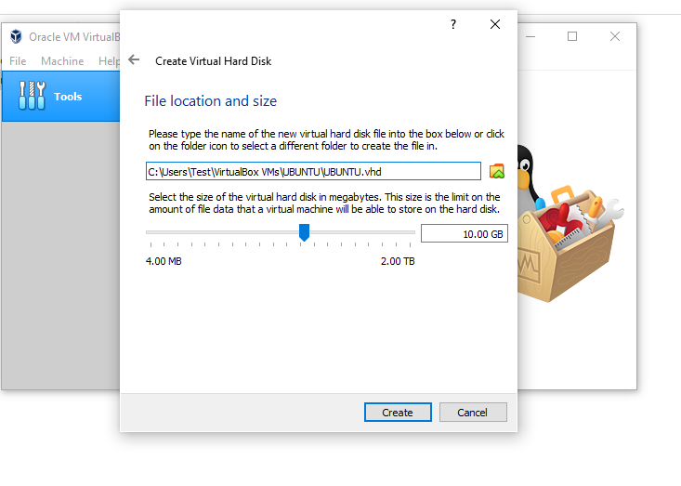

**STEP 16**

Click on Settings

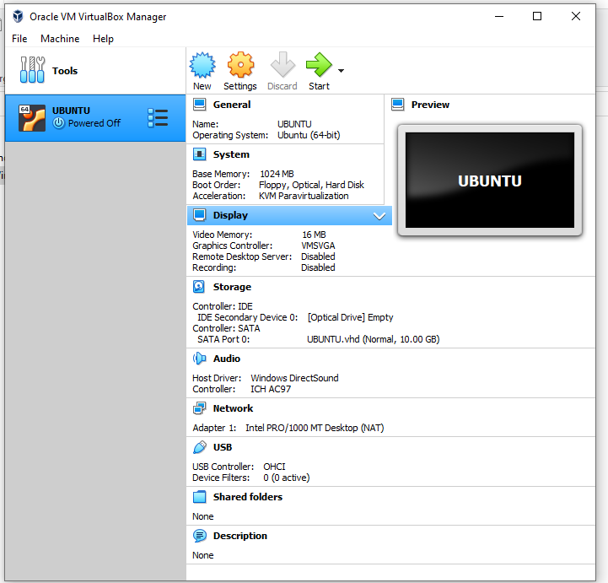

**STEP 17**

Click on Storage and then click on Empty disk under Controller:IDE – choose iso image file of Ubuntu then  
Disk image on right side(Optical drive option)

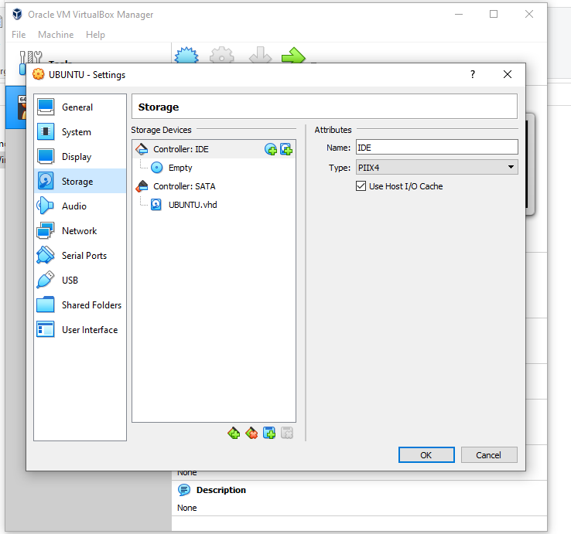

**STEP 18**

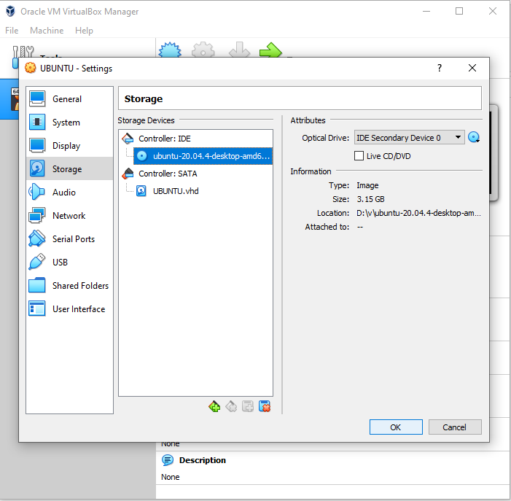

**STEP 19**

Setup is complete click on Start

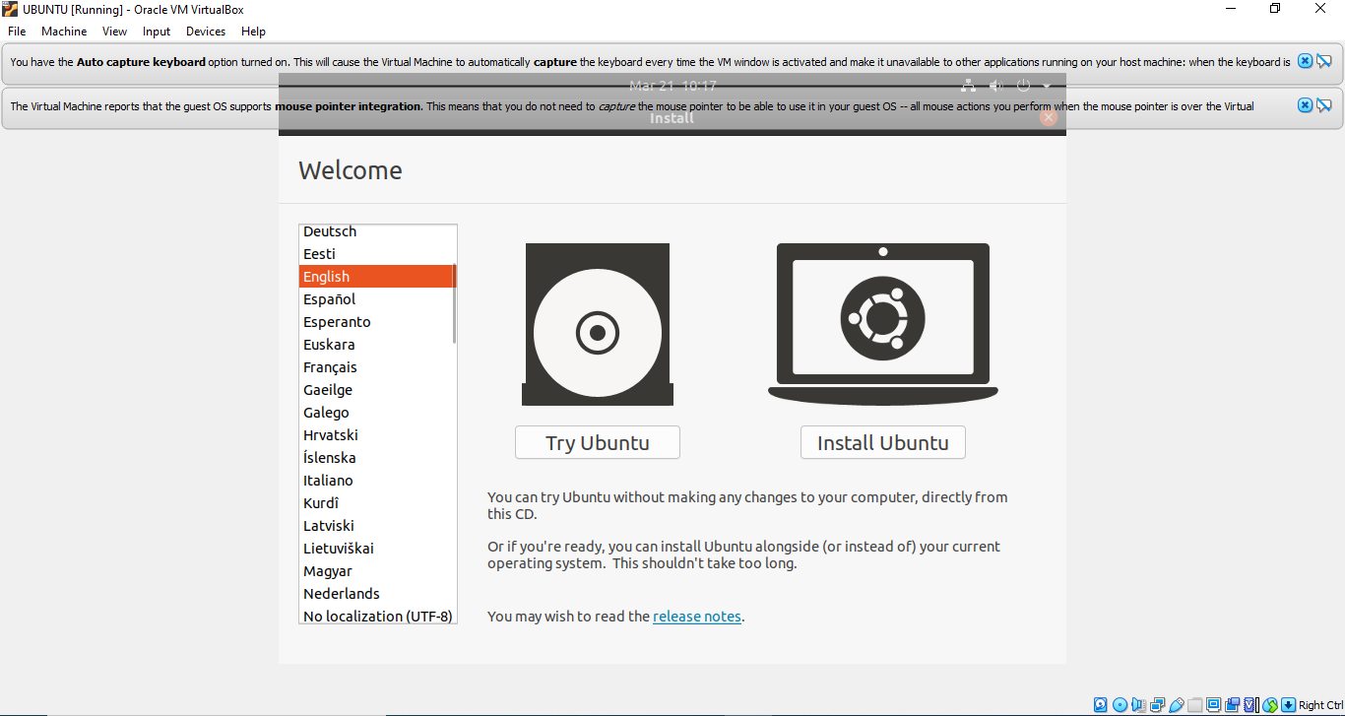

Click on Install Ubuntu

**STEP 20**

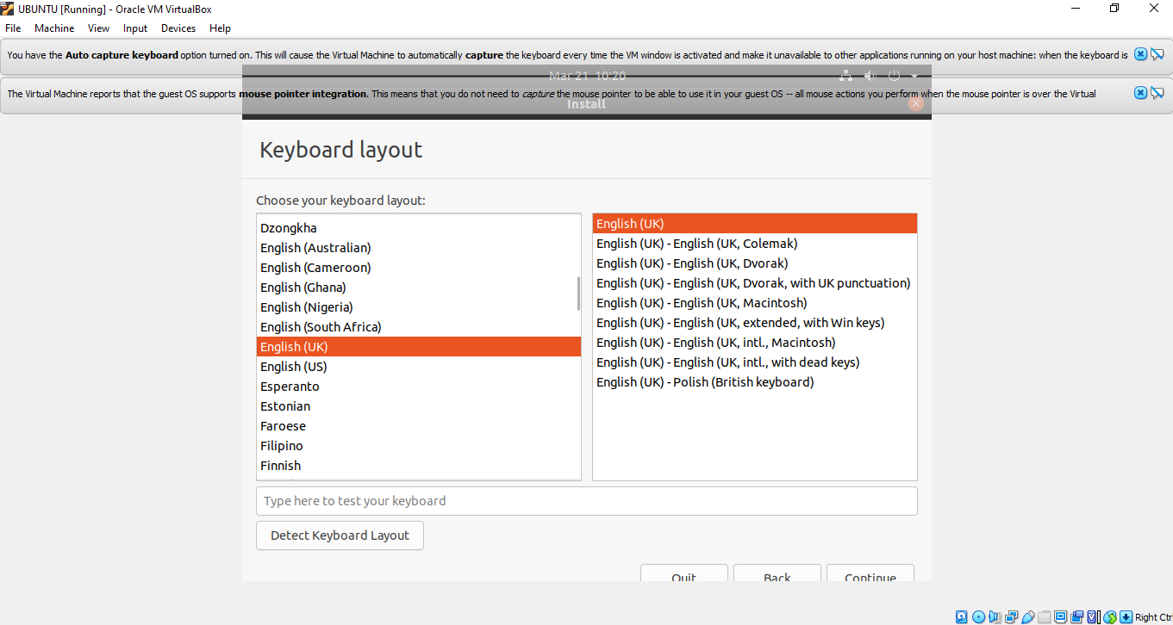

**STEP 21**

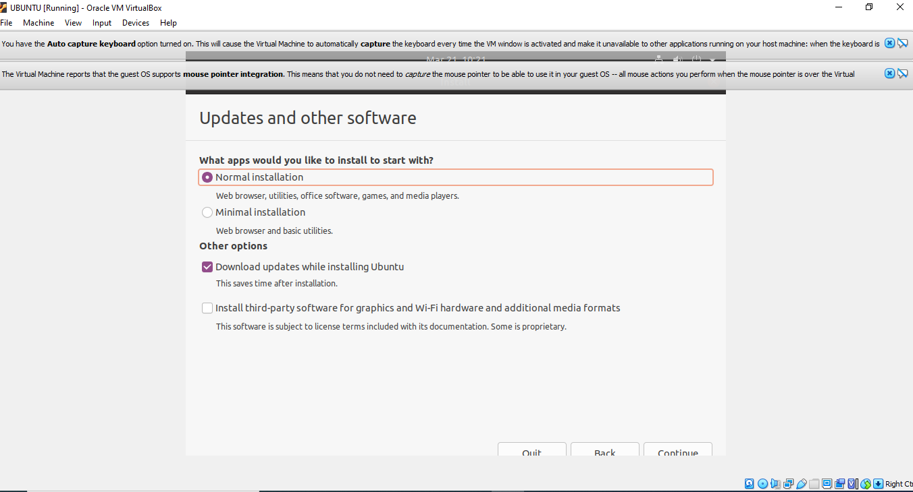

**STEP 22**

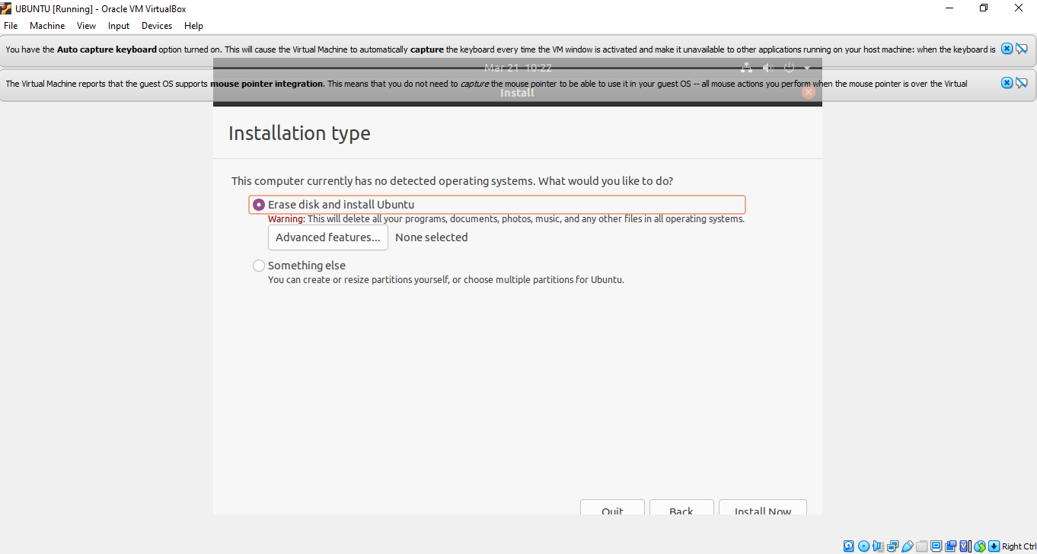

Click on “Install Now” prompt.

**STEP 23**

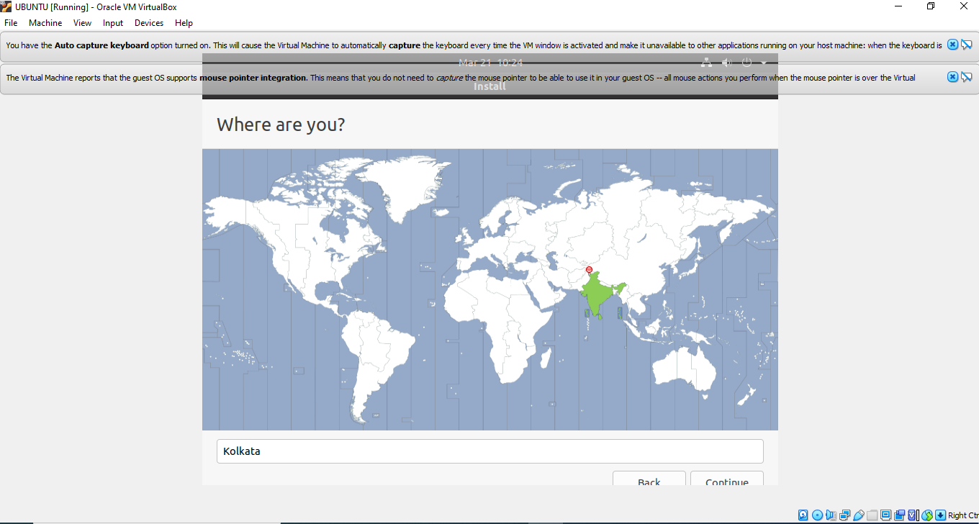

**STEP 24**

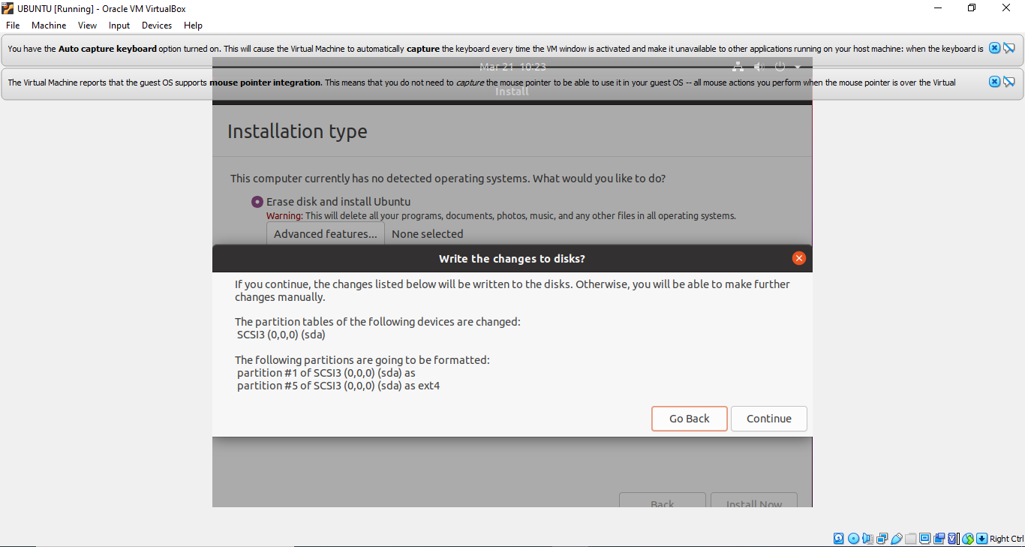

**STEP 25**

Set your username and password to login to the system. Make sure you choose a strong password with alphanumerics and symbols.

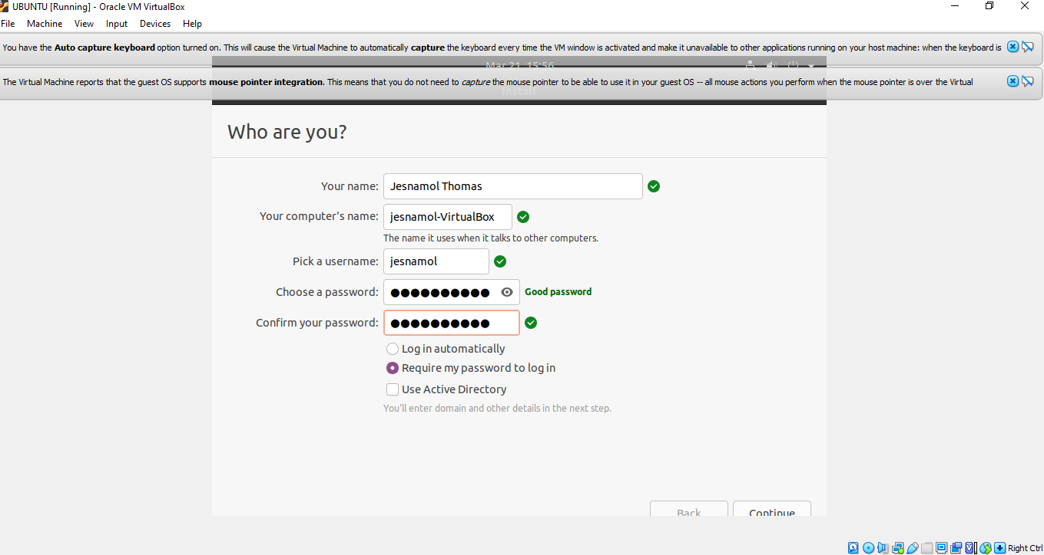

Click on Continue and the installation will start.

**STEP 26**

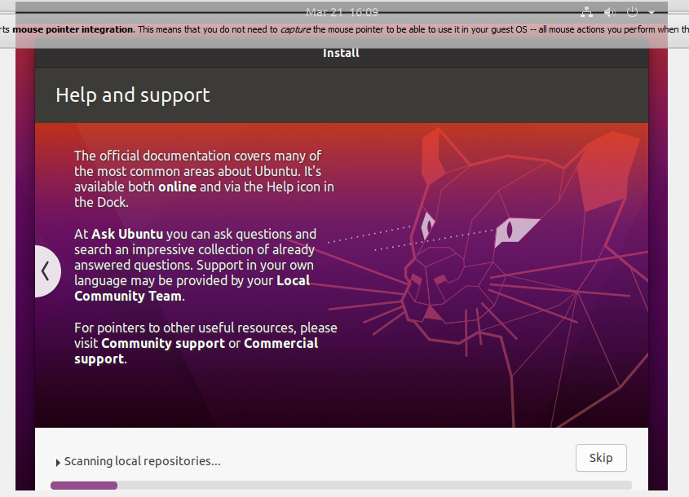

**STEP 27**

If your installation is complete with no intermediate obstacle, a success notification will pop up. You can now restart and login to your Ubuntu virtual machine.

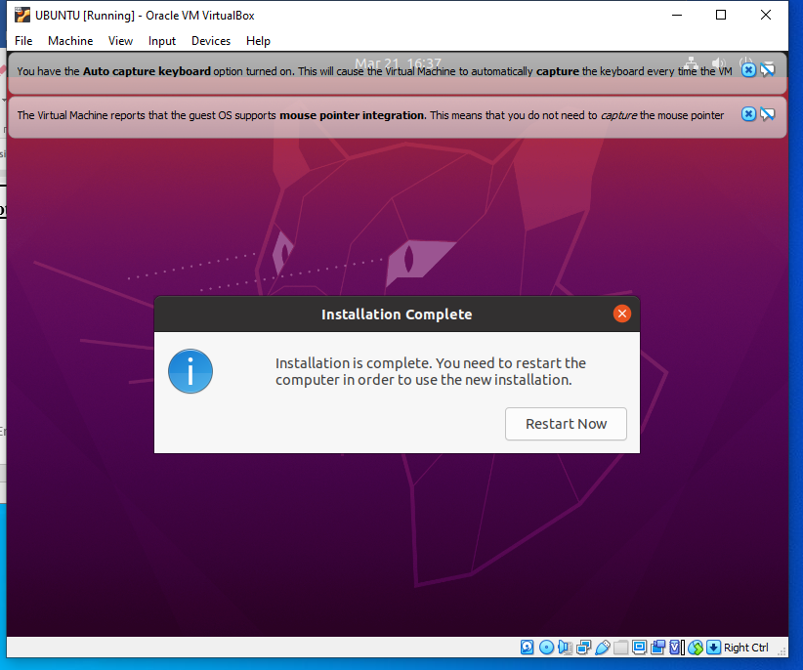

**STEP 28**

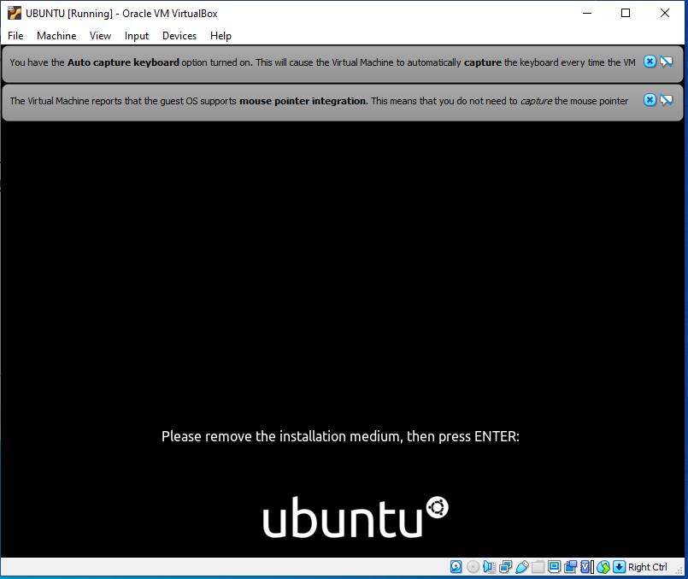

**STEP 29**

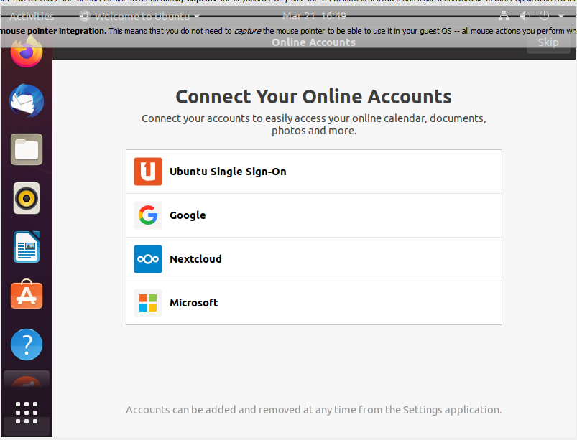

**Output Screenshot**

